Feyi Raimi-Abraham

Word count: 500

**Prince Twins Seven Seven (May 3, 1944 – June 16, 2011)**

Prince Twins Seven Seven was a Yoruba artist of the Oshogbo School. He is one of the most significant artists of modern art in Africa. Twins’s work is deeply influenced by Yoruba culture and mythology. His work is also influenced by the writings of the Yoruba folklorist Amos Tutuola. Emerging at a time when indigenous religions were being rejected in favour of Christianity and Islam, the Oshogbo School gave artists like Twins the platform to defy the norm by portraying images of native beliefs and deities. Twins is important to African modern art as a foremost artistic custodian of Yoruba heritage. His work is featured in major collections and exhibitions world-wide. In 2005, he was appointed UNESCO Artist for Peace in recognition of his contribution to the promotion of dialogue and understanding among peoples. Born in Ogidi, Twins’s career started in music and theatre arts. Whilst developing his painting and sculpting skills with the Mbari Mbayo Group in Osogbo during the early 1960s, Twins also attended workshops given by Susan Wenger, Ulli Beier and Georgina Beier. Initially drawing with ink on paper, Twins turned his art to modern art by creating abstract works and using various materials, techniques, and colours.

The legend of Twins’s birth is another influence on his work. His mother believed that he was an abiku – a child that dies in infancy, and continues the cycle of birth and death until cured by a native doctor. This is depicted in *Healing of Abiku Children* (1973). Other prominent works include *Baby Naming Ceremony* (1990), and *Three Wise Ocean Gods: Air, Sea, Nature Controller* (1990) depicting three Yoruba deities, possibly Olorun flanked by Oya and Yemaja. Themes of Yoruba heritage are absent in some of his works which portray national social issues and cultures of other Nigerian tribes. In *Argungu Fishing Festival* (unknown date) he depicts the annual fishing competition that takes place in the North-western Nigerian town of Argungu. Similarly in *Motorcycle Accident* (1969) Twins refers to one of the most common and controversial occurrences in Nigeria. The motorcycle, okada, is often seen as the cause of many fatal road accidents in all regions of the country. He was for a time married to the artist Nike Davies-Okundaye. In the late 1980s Twins left Nigeria and eventually settled in Philadelphia. After a turbulent period and becoming destitute, Twins found work as a parking attendant at Material Culture where he was rediscovered as an artist. In the mid-2000s, he returned to live in Nigeria and settled in Ibadan, where he died on 16 June, 2011, aged 67.

**References and further reading**

Pemberton III, J. (2002) Ulli Beier and the Oshogbo Artists of Nigeria, African Studies Review vol. 45, No. 1: 115-124. African Studies Association  
Article Stable URL: <http://www.jstor.org/stable/1515010>  
  
Glassie, H. (2010) *Prince Twins Seven-Seven: his art, his life in Nigeria, his exile in America*, Indiana University Press.  
  
Mundy-Castle, A.C. and Mundy-Castle, V. (Autumn, 1972) Twins Seven Seven, African Arts, Vol. 6, No.1: 8-13  
  
New York Times obituary July 3, 2011:  
<http://www.nytimes.com/2011/07/04/arts/design/prince-twins-seven-seven-nigerian-artist-dies-at-67.html?adxnnl=1&ref=deathsobituaries&adxnnlx=1387462027-d+y75y+lt3o3PkY7KQj7SQ&_r=0>  
  
Video clip of Prince speaking about Healing of Abiku Children: <http://www.youtube.com/watch?v=AzgfvqJFElg>  
Indianapolis Museum of Art are likely to be the copyright holder  
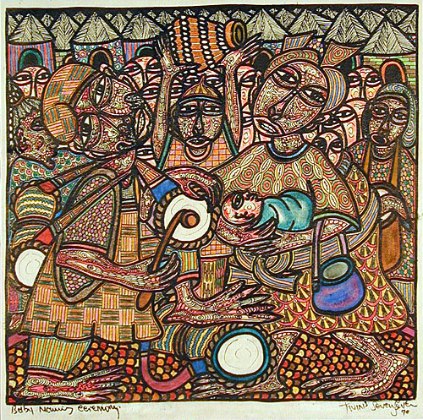  
url: http://www.indigoarts.com/gallery_twin77_55.html  
Baby Naming Ceremony  
Twins Seven Seven (1944 – 2011), Oshogbo, Nigeria  
Digital pigment print of 1990 original painting.  
(Epson 9800 Ultrachrome K3 Pigment Print on “English 14” Cold Press Art Paper)  
14 ¾”h x 15 ¼”w  
possible copyright holder: <http://www.indigoarts.com>